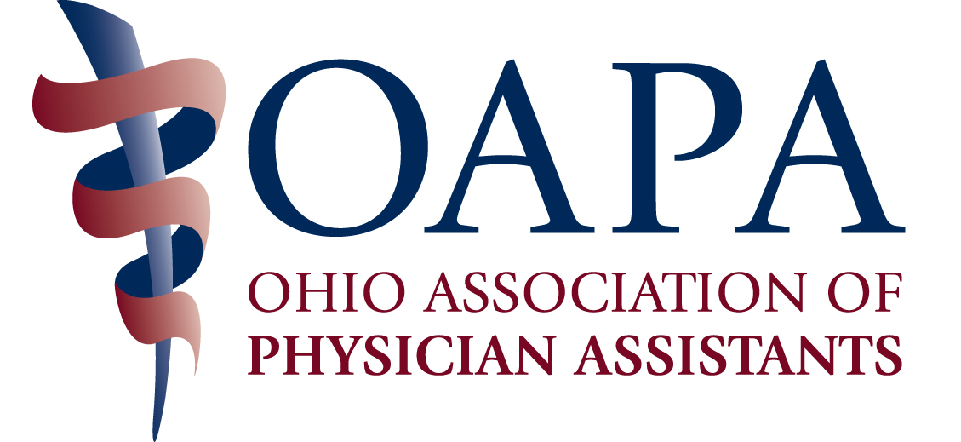

OAPA ANNUAL CONFERENCE – OCTOBER 10-12, 2014
Marriott Columbus Northwest, Dublin, OH

AGENDA

"OAPA is applying for 20 CME credits. Total number of approved hours yet to be determined."

Friday, October 10

7:00 – 8:00 Registration and Continental Breakfast
8:00 – 9:00 Heroin Epidemic and Opioid Abusers
9:00 – 10:00 Pediatrics
10:00 – 10:30 Break w/Detail Tables
10:30 - 11:30 GI Alphabet Soup
11:30 – 12:30 Assessing a Pulmonary Nodule and Lung Cancer Update
12: 30 – 1:30 Lunch
1:30 – 2:30 Chemotherapy Induced Cardiac and Pulmonary Toxicities
2:30 – 3:30 Primary Care Treatment for Mood Disorders
3:30 – 4:00 Break w/Detail Tables
4:00 – 5:00 Wound Therapy
5:00 – 6:00 “Zebra” Conditions
6:00 – 6:30 Cocktail Reception (Tentative)
6:30 – 10:30 Dinner and Casino Night

Saturday, October 11

7:00 – 8:00 Breakfast and Registration
8:00 – 9:00 Shared Medical Appointments
9:00 – 10:00 Genetic Testing for Colon Cancer Syndromes
10:00 – 10:15 Break
10:15 – 11:15 Non-cardiac Chest Pain
11:15 – 12:15 Treatment of Osteoarthritis/Rheumatoid Arthritis
12:15 – 1:30 Lunch w/Business Meeting
1:30 – 2:30 Cardiac Clearance and Precautions for Surgery
2:30 – 3:30 Contraception and Infertility
3:30 – 3:45 Break
3:45 – 4:45 Women’s Preventative Health
4:45 – 5:45 Diversity and Cultural Competence

Sunday – October 12

7:00 – 8:00 Breakfast and Registration
8:00 – 9:00 Wheat, the Staff of Life?
9:00 – 10:00 Happy Hour: Substance Use and Other Behavioral Issues
10:00 – 10:15 Break
10:15 – 11:15 SCIP Data Reporting
11:15 – 12:15 Hip Reconstruction in Adults

REGISTRATION FORM

NAME _________________________________________________________________

YOUR FIRST NAME FOR YOUR NAME BADGE_____________________________

YOUR PRACTICE SPECIALTY FOR YOUR NAME BADGE____________________

MAILING ADDRESS _____________________________________________________

CITY/STATE ____________________________________________________________

PHONE ____________________________EMAIL______________________________

SPECIAL NEEDS ________________________________________________________

Inclusive (Friday, Saturday and Sunday) Conference Rates:
Includes All Meals and Breaks – Does NOT Include Printed Syllabus

Pre-Registration After 10/03/14 and
Deadline 10/03/14 On-Site Registration

OAPA Member $400 $500 $ ______
Non-member $550 $650 ______
(Includes Optional 1 Year OAPA Membership)
OAPA Student Member $200 $200 ______
Student Non-member $225 $225 ______

Daily Rates:
Friday, October 10 OR Saturday, October 11 Specify Day ______

OAPA Member $160 $200 $ ______
Non-member $220 $260 ______
OAPA Student Member $100 $100 ______
Student Non-member $125 $125 ______

Sunday, October 13

OAPA Member $ 80 $100 $ ______
Non-member $110 $130 ______
OAPA Student Member $ 0 $ 0 ______
Student Non-member $ 10 $ 10 ______

Printed Syllabus $ 10 $ ______

Guest for Friday Dinner and Casino Night - $50 $ ______

TOTAL: $ ______

The Non-member rate includes an optional 1 Year Membership in OAPA.
YES, I would like a membership _________ NO, I would not _________

I will attend the dinner and Casino Night YES_________NO__________
Dinner and Casino Night is included in the registration fee. There is an
additional charge for guests.

This is this FIRST OAPA conference I have attended. YES____ NO____

REGISTRATION PAYMENT

Make Checks Payable to OAPA

Visa or MasterCard ONLY:
Credit Card #________________________________________Exp. Date ____________

Signature________________________________________________________________

Mail Registration Form and Payment to:
OAPA
4700 Reed Road, Suite N
Columbus, OH 43220

You may also register with a credit card on line at the OAPA website:
www.ohiopa.com
or fax with a credit card to 614/824-2103

Questions? Call OAPA at 800/292-4997

Full refund (minus $25 processing fee) available upon written request, postmarked on or before October 4, 2013. No refunds after OCTOBER 3, 2014. No refunds for no shows.

HOTEL INFORMATION

Hotel Room Rates: $118.00

Mention OAPA when you contact the Marriott Columbus Northwest to make your room reservations – 888-801-7133. Hotel Registration Deadline is September 12, 2014.

