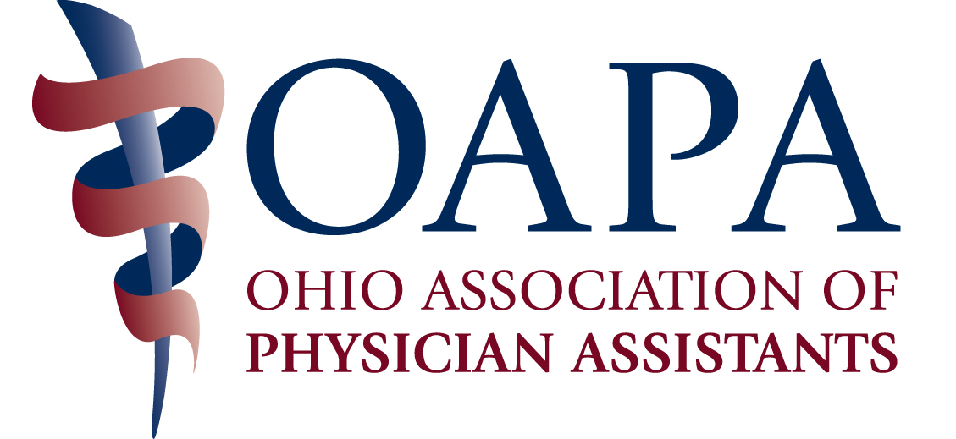

Reimbursement and Utilization of Physician Assistants in Hospital and Outpatient (private) Settings

A seminar explaining ways to maximize the reimbursement and utilization of PAs in practice.

Friday, February 19, 2016
8:30 AM – 12:45 PM

Embassy Suites
5100 Upper Metro Place
Dublin, OH
614/790-9000

$85.00 Per Person

Register online at www.ohiopa.com today!

Questions? Contact OAPA at 800/292-4997 or oapa@ohiopa.com

Speakers:

Michael Powe, BS
VP of Reimbursement and Professional Advocacy, AAPA

Josanne Pagel, MPAS, PA-C
Executive Director of PA Services, Cleveland Clinic

Additional information on seminar content below.

All participants will learn about:
- Reimbursement and coverage rules related to Medicare, Medicaid, and private third party payers
- Update on new laws governing PAs
- Credentialing and privileging
- Joint Commission requirements
- Medicare's condition of participation regulations
- The training, certification, licensing and privileging for PAs
- Measures necessary before a PA begins practice
- Four areas of utilization of PAs in your system
- Reporting structures of the PA to physicians and administrators

Hospital administrators will learn to understand and develop the productivity expectations and metrics by which the value of PAs' is assessed within the institutions and learn the answers to FAQ's:
- What is shared billing and what are the regulatory requirements imposed by Medicare?
- When is it appropriate to bill "incident to"?
- Are PAs able to bill high level CPT evaluation and management codes? What about consultations?
- How will PAs fit into fee-for-value reimbursement systems such as bundled and episodic payment models?
- What are the key risk areas for allegations of fraud and abuse?
Seminar Speakers:

Michael Powe, Vice President of Reimbursement and Professional Advocacy for the
American Academy of Physician Assistants.

Mr. Powe works with health care policy issues, third party payment concerns and Medicare, Medicaid programs and various State and Federal regulatory Agencies.
He also serves as AAPA's staff liaison to the American Medical Association's CPT Editorial Panel and Relative Value Update Committee. He is the author if the book, Physician Assistant Third Party Coverage and is an adjunct assistant professor at the George Washington University Division of Health Sciences in Washington DC.

Josanne Pagel, Executive Director of PA Services, Cleveland Clinic

Josanne Pagel is the Director of PA Services at the Cleveland Clinic. She oversees PA practice, policy, reimbursement and onboarding of new PAs. She serves as the Chairperson of the Governmental Affairs committee and Pharmacology CME Conference committee of the OAPA. She consults with large hospital systems throughout the U.S. on best practices for PAs. Josanne sits on various admission committees for PA programs and is a registered Karuna Reiki Master and Teacher. Josanne is the Secretary/Treasurer of the American Academy of PAs sits on various admission committees for PA programs. She is also a Distinguished Fellow of the AAPA.
This program has been reviewed and is approved for a maximum of 4.00 hours of AAPA Category 1 CME credit by the Physician Assistant Review Panel. Physician assistants should claim only those hours actually spent participating in the CME activity.
This program was planned in accordance with AAPA's CME Standards for Live Programs and for Commercial Support of Live Programs.
This program has been approved and meets AAPC guidelines for 4.0 Core A continuing education units.

