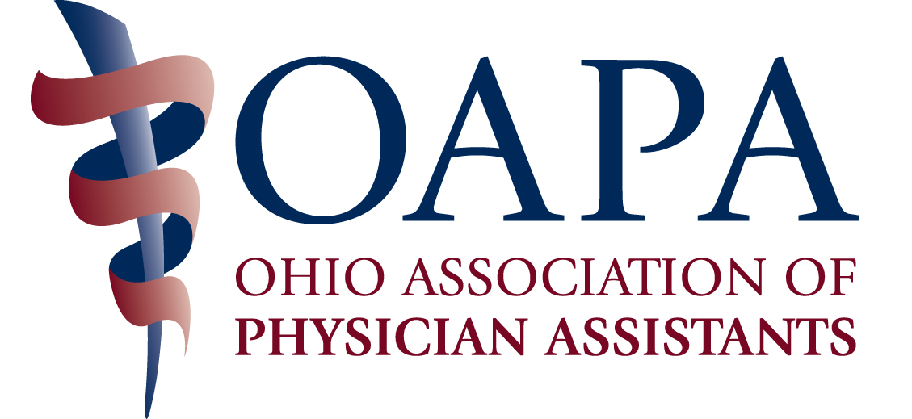

OAPA ANNUAL CONFERENCE – OCTOBER 2-4, 2015
Marriott Columbus Northwest, Dublin, OH

AGENDA (Subject to Change)

"OAPA is applying for 20 CME credits. Total number of approved hours yet to be determined."

Friday, October 2

7:00 – 8:00 Registration and Continental Breakfast
8:00 – 9:00 Pain Management: Non-Opiate Options
9:00 – 10:00 Classes of Cardiac Medications
10:00 – 10:30 Break w/Detail Tables
10:30 - 11:30 NPR and Dermatology: A Cutaneous Look at the News
11:30 – 12:30 Breast Cancer Surgery
12: 30 – 1:30 Lunch
1:30 – 2:30 Dizziness and Balance System
2:30 – 3:30 Hidradenitis and Antibiotic Overuse
3:30 – 4:00 Break w/Detail Tables
4:00 – 5:00 Irritable Bowel Diagnosis and Treatment
5:00 – 6:00 Current Treatmentsof Hepatitis C
6:00 – 6:30 Cocktail Reception
6:30 Dinner on your own

Saturday, October 3

7:00 – 8:00 Breakfast and Registration
8:00 – 9:00 Emergency Medicine
9:00 – 10:00 Shoulders
10:00 – 10:15 Break
10:15 – 11:15 Poverty as a Social Health Determinant
11:15 – 12:15 The ABCs of Hematopoetic Cell Transplant
12:15 – 2:00 Lunch w/Business Meeting and Report on SB110
2:00 – 3:00 Geriatrics
3:00 – 4:00 Occupational Medicine
4:00 – 4:15 Break
4:15 – 5:15 The Art of Dying: Determining When Enough is Enough
5:15 – 6:15 Urology
6:15 Dinner on your own

Sunday – October 4

7:00 – 8:00 Breakfast and Registration
8:00 – 9:00 Zebra Talk
9:00 – 10:00 OPEP
10:00 – 10:15 Break
10:15 – 11:15 Dermatology
11:15 – 12:15 COPD

REGISTRATION FORM

NAME _________________________________________________________________

YOUR FIRST NAME FOR YOUR NAME BADGE_____________________________

YOUR PRACTICE SPECIALTY FOR YOUR NAME BADGE____________________

MAILING ADDRESS _____________________________________________________

CITY/STATE ____________________________________________________________

PHONE ____________________________EMAIL______________________________

SPECIAL NEEDS ________________________________________________________

Inclusive (Friday, Saturday and Sunday) Conference Rates:
Includes All Meals and Breaks – Does NOT Include Printed Syllabus

Pre-Registration After 9/25/15 and
Deadline 9/25/15 On-Site Registration

OAPA Member $400 $400 $ ______
Non-member $575 $675 ______
OAPA Student Member $200 $200 ______
Student Non-member $225 $225 ______

Daily Rates:
Friday, October 2 OR Saturday, October 3 Specify Day ______

OAPA Member $160 $160 $ ______
Non-member $260 $260 ______
OAPA Student Member $100 $100 ______
Student Non-member $125 $125 ______

Sunday, October 4

OAPA Member $ 80 $ 80 $ ______
Non-member $180 $180 ______
OAPA Student Member $ 0 $ 0 ______
Student Non-member $ 10 $ 10 ______

Printed Syllabus $ 10 $ ______

Guest - Friday Dinner/Casino Night $ 50 ______

TOTAL: $ ______

YES, I will attend the Friday Dinner and Casino Night ______________

This is this FIRST OAPA conference I have attended. YES____ NO____

REGISTRATION PAYMENT

Make Checks Payable to OAPA

Visa or MasterCard ONLY:
Credit Card #________________________________________Exp. Date ____________

Signature________________________________________________________________

Mail Registration Form and Payment to:
OAPA
4700 Reed Road, Suite N
Columbus, OH 43220

You may also register with a credit card on line at the OAPA website:
www.ohiopa.com
or fax with a credit card to 614/824-2103

Questions? Call OAPA at 800/292-4997

Full refund (minus $25 processing fee) available upon written request, postmarked on or before September 28, 2015. No refunds after SEPTEMBER 28, 2015. No refunds for no shows.

HOTEL INFORMATION

Hotel Room Rates: $120.00

Mention OAPA when you contact the Marriott Columbus Northwest to make your room reservations – 888-801-7133. Hotel Registration Deadline is September 24, 2015.

