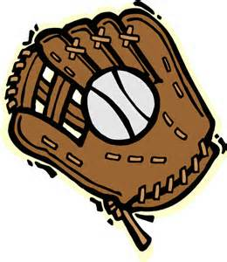 OAPA
Region 4
Meet & Greet
Bring your family & enjoy an evening at the Ball Park
Columbus Clippers
vs.
Indianapolis
July 27th, 2015
RSVP to OAPA by July 1st
(Limited Tickets Available)
oapa@ohiopa.com
614-824-2101 or 800-292-4997
HOPE TO SEE YOU THERE!
BRING A NON-MEMBER and BE ENTERED INTO A DRAWING

